Directions: Work with your partner(s) to explore and answer questions on your own paper or digital document. If you make a digital paper, you can insert images from the simulation to help support your ideas otherwise make sketches.

Learning Goals: Students will be able to
- Describe how the Energy Bar and Pie Charts relate to position and speed.
- Explain how changing the Skater Mass affects energy and speed.
- Explain the Conservation of Mechanical Energy concept using kinetic energy (KE) and gravitational potential energy (PE).
- Predict position or estimate speed from Energy Bar and Pie Charts.
- Explain how changing the Track Friction affects energy.
- Design a skate park using the concepts of mechanical energy and energy conservation.

Engage by using your knowledge of physics in your everyday life: Think about things that go up and down when you play. For example, you might throw a ball in the air, ride a skateboard, or a swing at the playground.
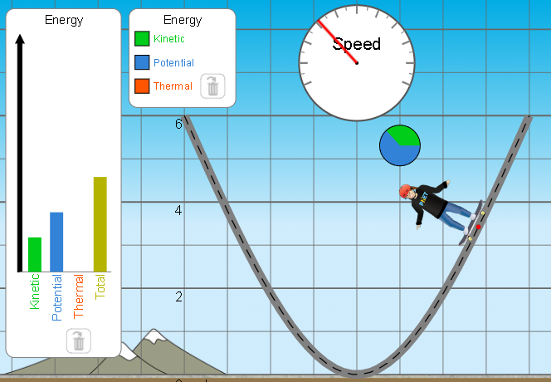

Look at this skater going down a frictionless track and use your experiences to fill in Table 1.
 | Table 1
 |  | Prediction | Describe your thinking
1 | Will the speed increase, decrease, or stay the same
2 | Will the kinetic energy increase, decrease, or stay the same
3 | Will the potential energy increase, decrease, or stay the same
4 | Will the thermal energy increase, decrease, or stay the same

Explore to develop your understanding:
- Play with Energy Skate Park Basics Intro screen to observe how the energies and speed changes as the skater moves.

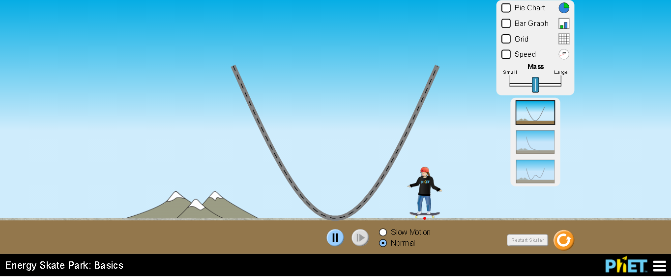
- Talk with your partner about how the buttons help you make observations.

- Design experiments to test your predictions from Table 1, then make a table like Table 2.
 | Table 2
 |  | Result of test | Describe your thinking
1 | Will the speed increase, decrease, or stay the same
2 | Will the kinetic energy increase, decrease, or stay the same
3 | Will the potential energy increase, decrease, or stay the same
4 | Will the thermal energy increase, decrease, or stay the same

Explore to develop your understanding about mass effects:
- How do you think changing the mass of the skater will change the results?

- Describe how you would test your ideas and then run trials to check your experiment plans.

- Explain how your results compare to your predictions and make drawings from the simulation to help describe the effects of mass.

Explore to develop your understanding about position effects:
- Try starting the skater at a few different heights to explore the skater’s speed and energies relationship to position. Summarize your tests and results use drawings for support.

Explain your understanding of learning goal A:
3. For each question make your prediction and explain your reasoning. Then, check your ideas using the simulation, describe how your ideas are supported or changed.

- If the skater’s speed is zero, what would you predict the bar and chart would look like?

- Where might the skater be when the speed is zero?

- What do you predict the speed, bar, and pie chart will look like when the skater is at the low point as shown?
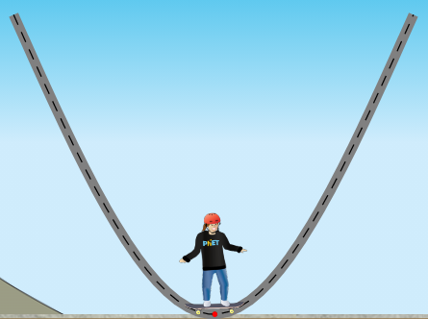

- Where might the skater be when the energies are equal?

- Summarize the relationship between position, energies, and speed.

Explain your understanding of learning goal C:
4. Research what Conservation of Mechanical Energy means and explain it in your own words. (Cite references)

5. Explain how the Conservation of Mechanical Energy can help you predict a skater’s speed, potential energy (PE), and kinetic energy (KE) when there is no friction on the track. Use ideas and results from your experiments in #2 and #3 to support your explanation.

Elaborate on your ideas by designing a skate park:
6. Play with Energy Skate Park Basics Playground screen talking about how the energy information can help you make a fun track and what tools help you run repeating trials.
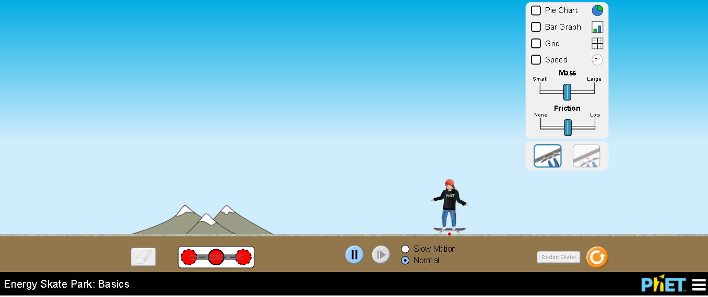

- Explain how you could use your understanding of Conservation of Mechanical Energy to plan a track that is fun, challenging and one that is relatively safe.

- Use your explanation in 6a to design a track using all 5 pieces of track. Test your track to make sure the skater will ride the entire track. Make edits to your thinking in 6a if you need. Show your teacher your track for credit.

Evaluate your ability to demonstrate the learning goals: The class will have an interactive discussion using the clicker questions.

Extension developing your understanding of more realistic physics:

Explore and Explain:
7. Play with Energy Skate Park Basics Friction screen to build an understanding of how a real skate park playground, which has friction, is more complex than an imaginary one with no friction. Think about how your ideas about the relationships between position, speed, and energies can be expanded. Summarize your observations and ideas about the relationships. Include images to support your ideas.

Evaluate your understanding: The class will have an interactive discussion using the clicker questions.

